**NASA responds to job application from boy, 9**

The youngster receives a letter after responding to an advert for the role of planetary protection officer.

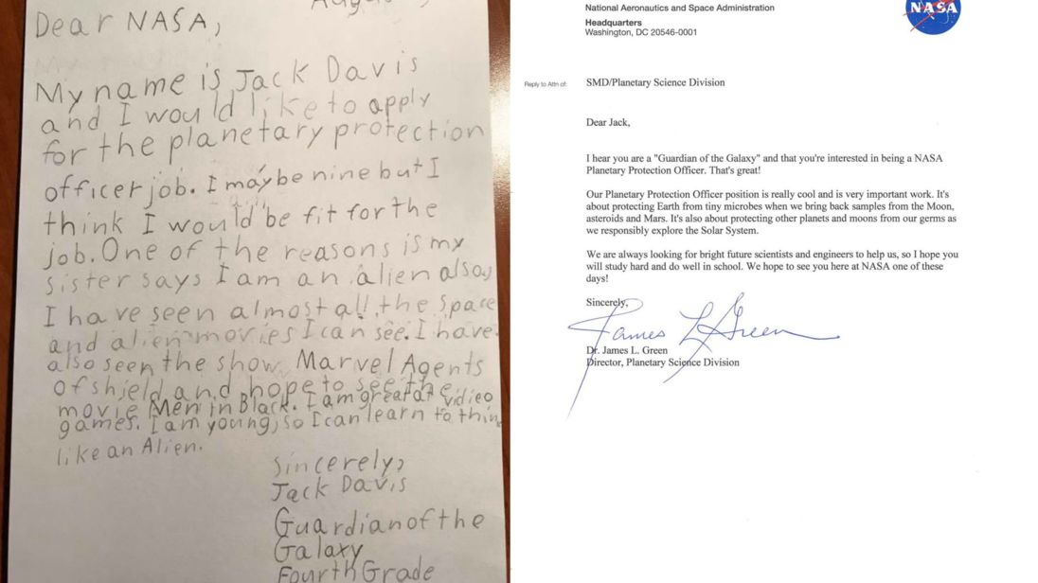

A nine-year-old boy received an encouraging response from NASA after he applied for the role of planetary protection officer.

Among the first applicants for the role was nine-year-old Jack Davis. He wrote to the space agency to explain:

"My name is Jack Davis and I would like to apply for the planetary protection officer job.

I may be nine but think I would be fit for the job.

One of the reasons is my sister says I am an alien also I have seen almost all the space and alien movies I can see.

I have also seen the show Marvel Agents of Shield and hope to see the movie Men in Black.

I am great at video games.

I am young, so I can learn to think like an Alien.

Sincerely,Jack DavisGuardian of the GalaxyFourth Grade"



……………………

Jack in turn received a letter from the eminent Dr James L Green, the director of NASA's planetary science division:

Dear Jack,

I hear you are a 'Guardian of the Galaxy' and that you're interested in being a NASA Planetary Protection Officer. That's great!

Our Planetary Protection Officer position is really cool and is very important work. It's about protecting Earth from tiny microbes when we bring back samples from the Moon, asteroids and Mars. It's also about protecting other planets and moons from our germs as we responsibly explore the Solar System.

We are always looking for bright future scientists and engineers to help us, **so I hope you will study** hard and do well in school. We hope to see you here at NASA one of these days!

Sincerely,Dr. James L. GreenDirector, Planetary Science Division

