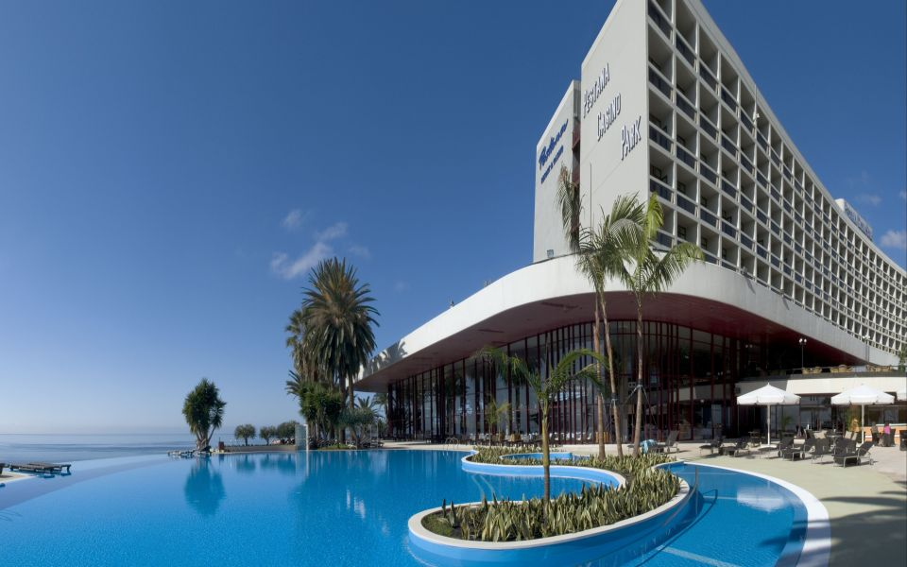

Dear Ms. Wells,

I am writing on behalf of the entire Taylor family to thank you and your wonderful staff for making my parents, Sam and Darla Norton’s, surprise anniversary celebration the event of a lifetime. We did manage to pack for our parents and drive them from Columbia to Charleston for the surprise weekend that included the entire family. They are still talking about it a week later.

[Details]The flowers, chocolate dipped strawberries you placed in their suite were gorgeous and delicious, and the view was spectacular. The room that your catering manager, Bill Evans, set up for us was perfect, and we were all very impressed with the 50th anniversary decorations. The food was absolutely scrumptious and the cake was not only delectable, but a work of art as well. Your staff treated us like royalty at the anniversary dinner and their service was absolutely impeccable.

We cannot thank you enough for helping us arrange my parents’ vow renewal ceremony in your beautiful gardens. I could not have found a more perfect setting anywhere. We were all pleasantly surprised at the lovely flowers you were able to display in the garden in spite of the crisp November weather. Also, the refreshments at the ceremony were delicious and arranged in such an appealing presentation.

I have already referred your hotel to one of my friends who lives in Charleston as she looks for a place to host son’s wedding rehearsal dinner. In addition to the amazing food, service and accommodations, your prices are quite reasonable which made our event even better.

Thank you again for contributing to the Taylor family’s cherished memories.

Sincerely,

Sarah Taylor

Sarah Taylor