**The Lehman anniversary**

**Five years in charts**

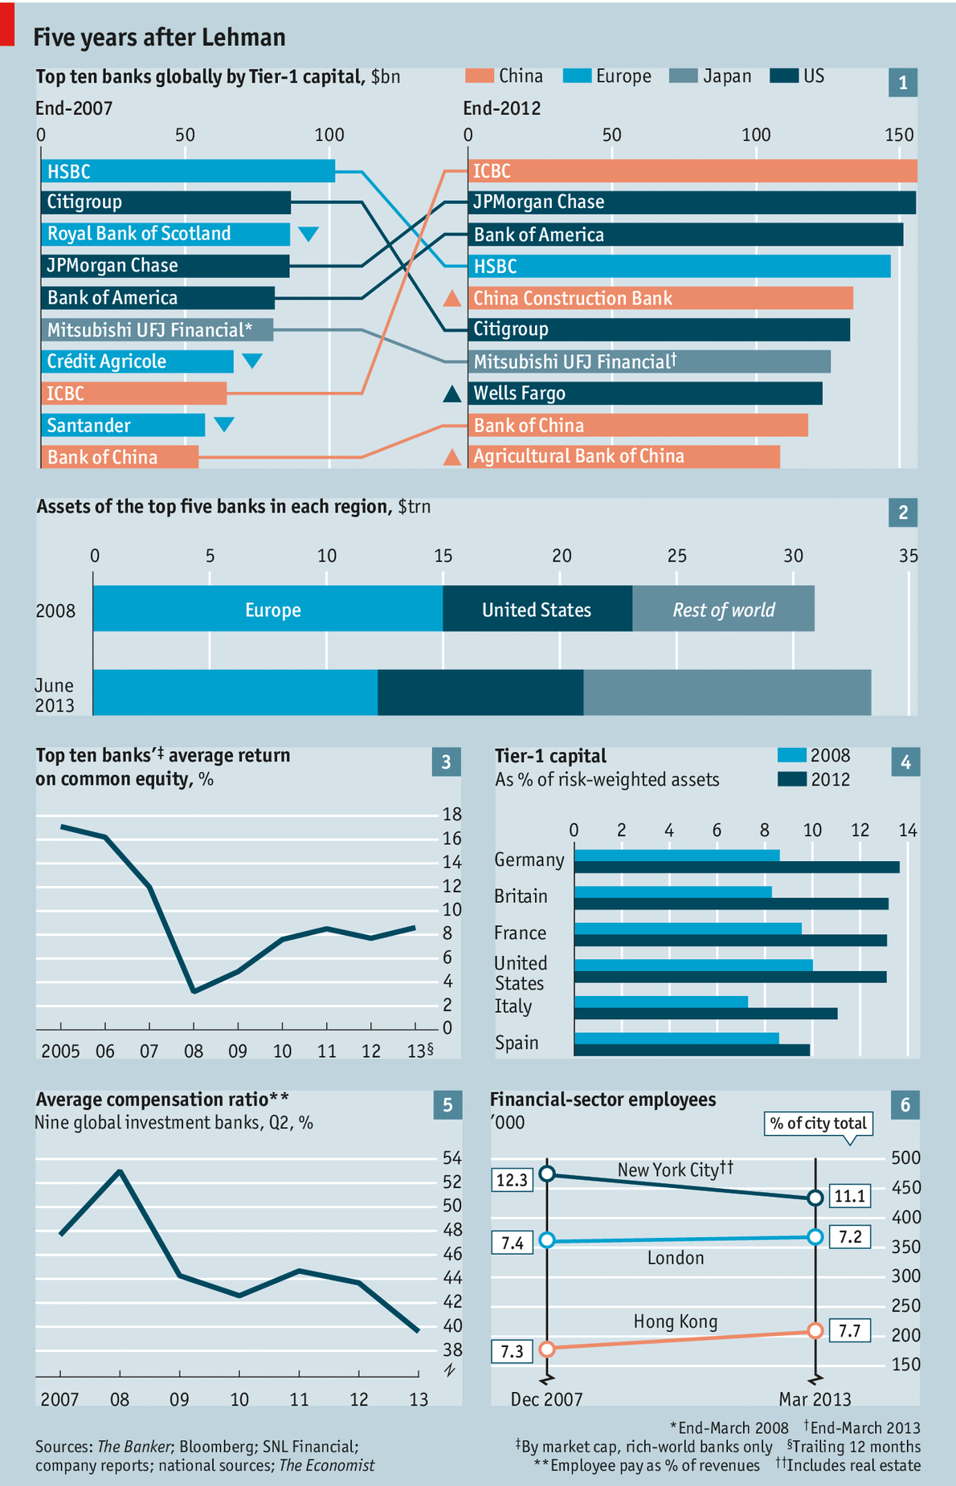

The world of banking has changed dramatically***, if not radically,*** in the five years since September 15th 2008, the day Lehman Brothers went bust. American and European banks used to dominate the list of the world’s biggest banks (see chart 1); the Chinese have since scaled the charts. The balance-sheets of Europe’s behemoths ***have got quite a bit smaller*** (chart 2); consolidation has made America’s giants bigger than ever. Western banks are generating much lower returns on equity than they did in the years before the crisis (chart 3), **in part** because the industry is being forced to fund itself with higher levels of equity than in the past (chart 4). So cost-cutting is much more important than it was: compensation ratios at investment banks **have fallen considerably** (chart 5). But those who want a complete reshaping of finance can still argue that change has not gone far enough: more people work in finance in London in 2013 **than did** in December 2007 (chart 6).

***Comment:***

***Pay exclusive attention to the differences between "dramatically" and "radically" in business data description; they concentrate on the "volume" and "speed" respectively.***