Starved for cash

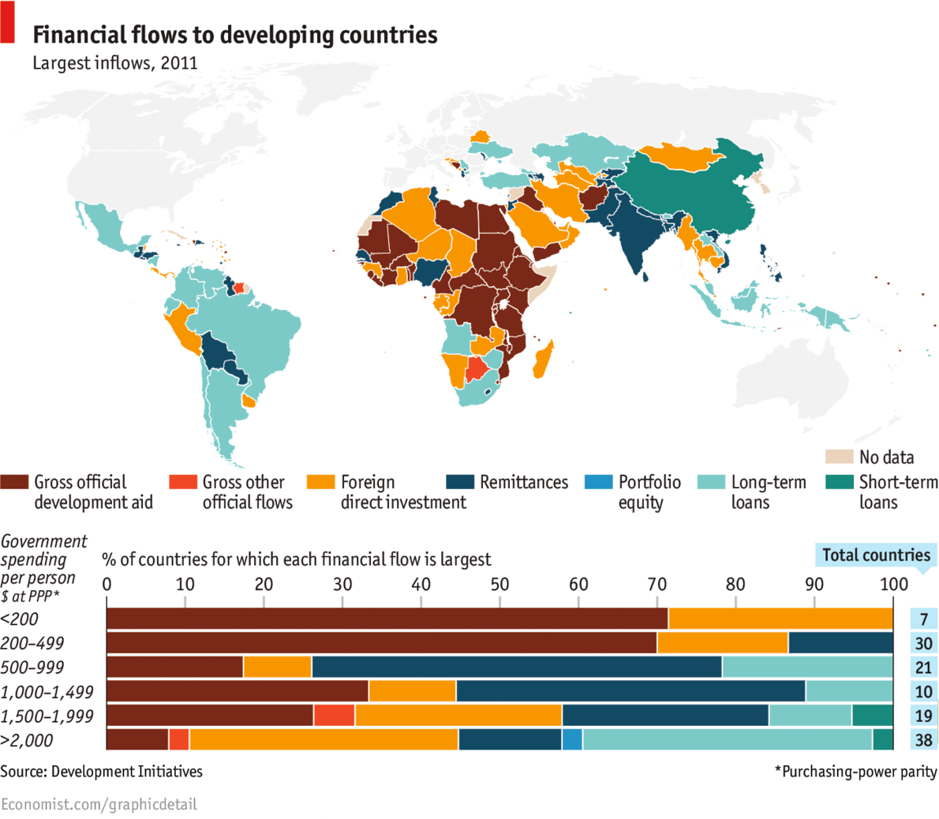

***The more poor countries spend, the more they get***

THE flow of money to poor counties has surged over the past two decades, from under $500 billion in 1990 to over $2 trillion in 2011. For the poorest, official development aid is the main source of funds. But those governments that spend more see a greater diversity of funds flow into the country -- not just aid, but lending, remittances and foreign direct investment. This is only natural: better-run countries are able to spend more and also have the capacity to attract other sources of funds. Unbundling the types of financial and aid resources going to poor countries is essential for identifying ways to eradicate poverty there, according to a new report by Development Initiatives, a think-tank. The data show that mature economies like Brazil and China rely on direct investment and lending. India, with a stock of productive emigrants, enjoys remittances. Africa depends most on aid: where government spending per person is less than $500 per year, aid represents about 70% of the financial resources from abroad.