**Silkworm Moth**

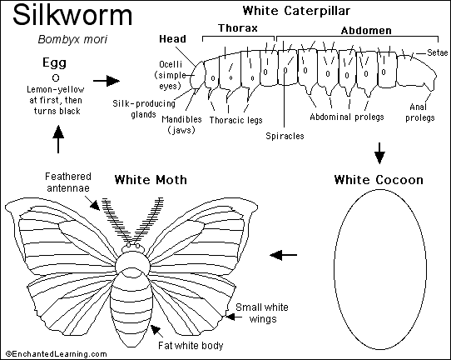

The Silkworm (*Bombyx mori*) is the caterpillar of a moth whose cocoon is used to make silk; it is not a worm at all. This insect is also called the silkworm-moth and the mulberry silkworm. It is native to Northern China.

**Silk**: The silk from the silkworm's cocoon is a single, continuous thread. It is made of a protein that is secreted from two salivary glands in the caterpillar's head. To harvest silk, the silkworm is allowed to spin its cocoon and it is then put in boiling water to kill the pupa and help unravel the thread. Each cocoon contains a single silk thread that is about 300 to 900 meters long. The adult moth cannot eat or fly; it has a fat body and small wings.

**Lifecycle**: The tiny Silkworm larva hatches from a tiny black egg. The larva eats mulberry (*Morus alba*) leaves almost constantly for 4 to 6 weeks until it is 2 3/4 inches long. The white caterpillar molts its skin many times during this stage. The caterpillar then pupates; it spins a white silk cocoon around itself (in a process taking 3 or more days). The silk covers a hard brown-shelled pupa. In roughly three weeks, the adult moth emerges. This white moth cannot fly; it reproduces and dies within about five days (the female lays from 200 to 500 lemon-yellow eggs that eventually turn black).

Comment :

Pay special attention to the very use of the present tense in describing the processes as well as the regular punctuation used for such process.