**Less skewed**

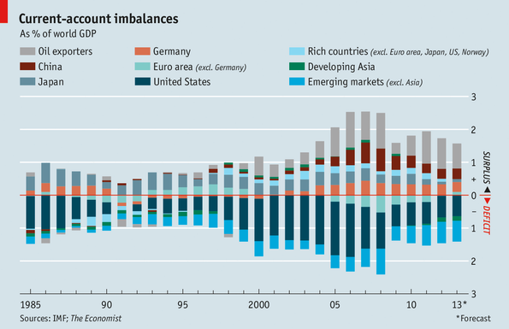

In the run-up to the financial crisis the world economy was marked by huge current-account imbalances. China’s surplus alone **accounted for 0.7%** of global GDP in 2008; America **experienced** a deficit of **well over 1%** of world GDP that year. Since then the world has rebalanced. The current-account balances of the world’s big surplus economies **have totalled less than 2%** of global GDP since 2009, thanks partly to the strength of the Chinese currency and lower oil prices. Weak growth has cut European demand for imports. An energy boom has **helped reduce** America’s trade deficit, as a percentage of global GDP, to a 16-year low.