**Greenhouse Effect and Global Warming**

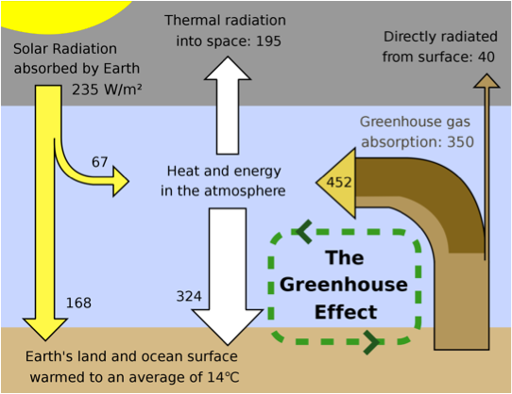

First, energy from the Sun **passes** through the atmosphere on its way to the surface of the Earth. A little bit of the solar energy **is absorbed** by the atmosphere on the way down (67 W/m2), but most **passes through** and **is thus absorbed** by the earth surface (168 W/m2).

Next, after the Earth's surface **absorbs** the solar energy, the surface temperature **rises** and the earth surface then **radiates** heat in a new form, which **is called** "infrared radiation". Some of this infrared energy **escapes out** into space . The rest of the infrared energy **is absorbed** by the atmosphere and **then re-emitted** down to the Earth's surface.

Scientists **believe** some particular gases in the atmosphere **capture** and then **re-emit** the infrared radiation back to the earth surface. These gases include: water vapor, CO2, CH4 & O3. Thus, the presence of these gases **results in** the earth surface**, receiving** more radiation. This **mimics** the function of a greenhouse and therefore, these gases **are called :**  " greenhouse gases" and the phenomenon **is called** " the greenhouse effect" .

This process **is** a natural aspect of the Earth's environment and **is** important for keeping the temperature on Earth at a normal level. (Not bad at all!) However, if the greenhouse effect **is heavily enhanced** by human activities, the increasing of the concentration of greenhouse gases **increases** the amount of absorption and re-radiation, and thereby **further warms** the surface below**, being** the major cause of global warming.

**Questions:**

1. Which verbs are simple present active?
2. Which verbs are simple present passive ?
3. Which verbs are reduced relative clause ?
4. Is there any dangling subject ?