**Global debt guide**

The debtors' merry-go-round

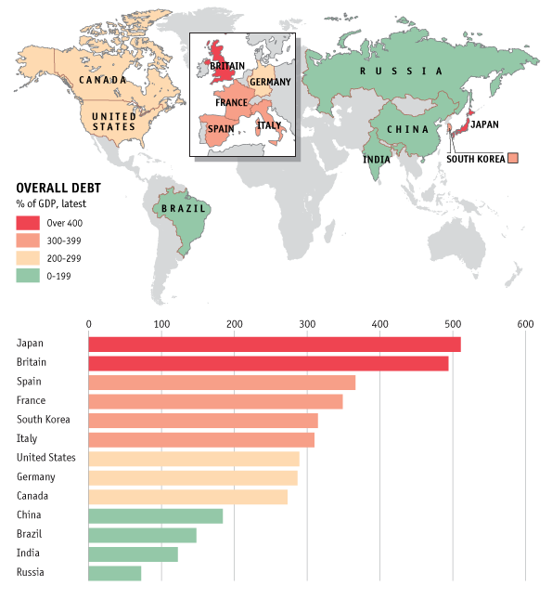

IN the years before the financial crisis, the rich world was surfing on a wave of private debt. Our interactive guide **shows** levels of debt as a percentage of GDP for a selection of rich countries and emerging markets. Between the first quarter of 2004 and the first quarter of 2009, private-sector non-financial debt **rose by an average of 43%** of GDP in the Western countries shown (excluding Germany). **Since** the crisis the debt burden **has spread** to the public balance-sheet. The costs of bail-outs and fiscal stimulus, and the effects of slow economic growth on tax revenues, **have sent** the ratio of government debt to GDP spiralling. The private sector **has at least begun** to deleverage: private-sector non-financial debt **has decreased by eight percentage** points on average in the past three years for those same six countries. But there is an awfully long way to go to turn back the clock.