Mar 7th 2013, 14:29 by Economist.com

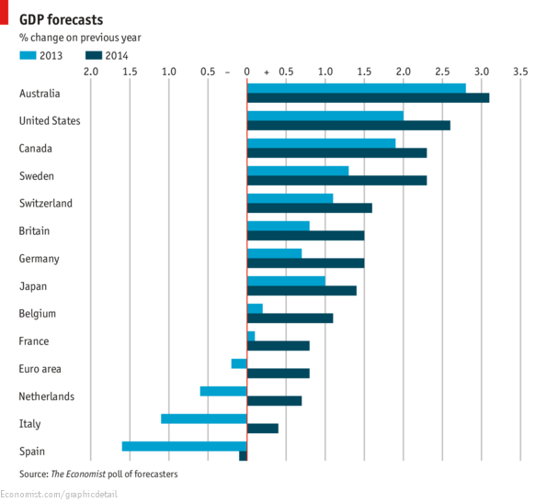

The Chart displays the Economist poll of forecasters for the years 2013 and 2014 .

OUR group of economists is marginally less pessimistic about GDP growth in 2013 than they were last month—for most of the countries in our poll, at least. The figures coming out of the euro zone still make dismal reading, however. Several economies are expected to contract this year, notably Spain and Italy which are forecast to shrink by 1.6% and 1.1% respectively. GDP in the euro area as a whole is expected to decline by 0.2% in 2013, a second consecutive year of contraction, before returning to tepid growth of 0.8% next year.  These figures look at odds with the buoyancy in many European stockmarkets this year, which are racing ahead due--- in part --to the strong performance of American markets. Across the board improvement in growth is expected by our forecasters in 2014 but this will be modest at best, with America expected to grow by 2.6% compared with more moderate growth of 2.0% this year.