**Financial services in developing countries**

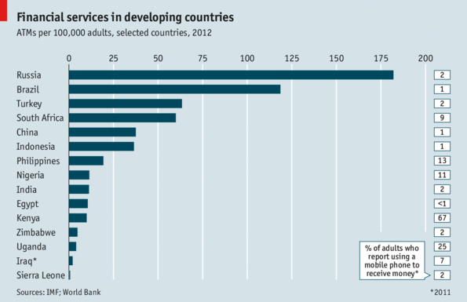

Access to traditional financial services, such as deposit-taking accounts and automatic teller machines (ATMs), in developing countries ***has expanded*** in recent years. Since 2004 the number of ATMs per 100,000 adults ***has more than doubled***, to around 22 (compared with over 70 in rich countries). Russia and Brazil have more ATMs relative to their population than other emerging markets, but according to a World Bank survey less than 2% of adults there used a mobile phone to receive money. Mobile payments are a substitute for traditional banking. In Kenya, where there are 2,381 ATMs (less than ten for every 100,000 adults), over ***two-thirds*** of people use mobile money.