**Empty stomachs**

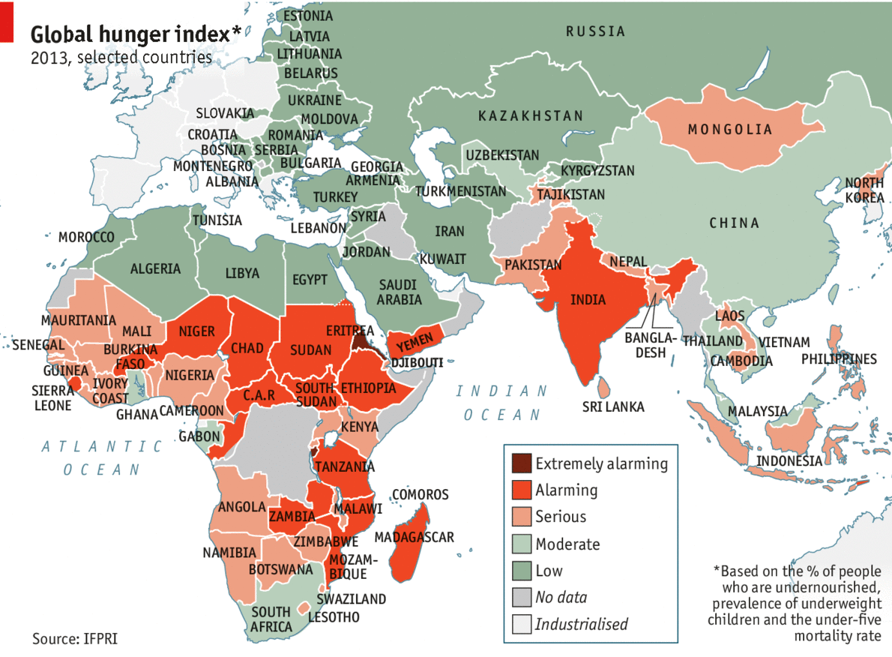

**Global hunger is decreasing, but not fast enough**

**ONE in eight** people, or 870m, went hungry in 2012, or 870m, according to a study by the UN's Food and Agricultural Organisation.  The Global Hunger  index covers 120 developing countries **that account for 84%** of the world’s population. While the overall world index has **decreased by 34%** since 1990, some 19 countries—with a total population of 1.6 billion—are classified as having "alarming" or "extremely alarming" levels of hunger.