**Dominant Research Universities**

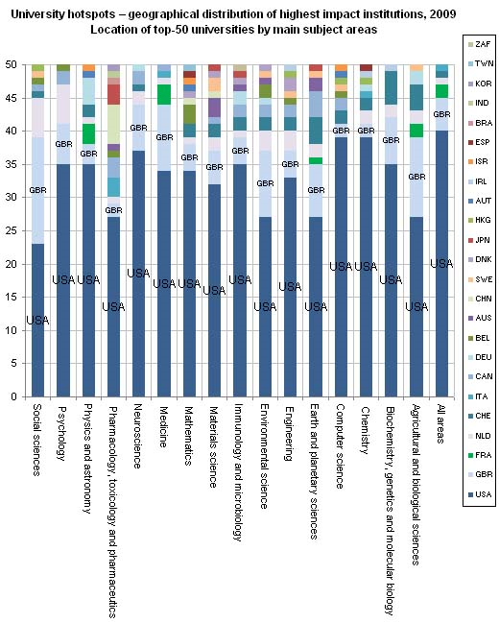

The chart --- based on new data from the Organization for Economic Cooperation and Development --- shows the distribution of the top 50 universities for a range of disciplines.

The darker blue bars at the bottom of the chart refer to American universities. And as **one** can see, at least at the post-secondary level, we still have some top-notch schools. In essence, for every discipline shown except for the social sciences, a majority of major research institutions are in the United States. Even in the social sciences a plurality of the top departments are based in the United States. Across all disciplines shown, 80 percent of the top research departments are in the United States. The next-highest share belongs to Britain (light blue bars), which is host to 10 percent of the world’s top research departments.