**Some simple observations...**

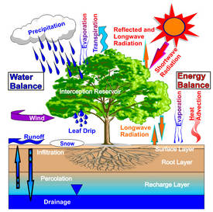

**There’s** a constant exchange between the Earth’s forests and its   
atmosphere of energy, water, and heat from CO2 and other chemical compounds. These exchanges **affect** the hydrological and thermal conditions of the atmosphere, as well as its chemical composition. A modification of these exchanges **has an effect on** the planet’s atmospheric circulation, and correspondingly, its climate.

Forests **are also home to** many kinds of bacteria, some of which **are carried** by the wind and **end up** interacting with clouds and catalyzing the formation of**, thus having** significantly influence on the climate and agriculture.

Deforestation **caused** by local populations in tropical regions releases CO2, the  
principal greenhouse gas **contributing to** global warming. According to experts  
from the Inter-governmental Panel on Climate Change (IPCC), deforestation is  
responsible for 10 to 15% of global emissions of greenhouse gasses. So slowing  
deforestation directly **helps** to slow climate change.

***Questions:***

1. What are simple present active verbs?
2. What are simple present passive verbs?
3. What are the cases of reduced relative clause?