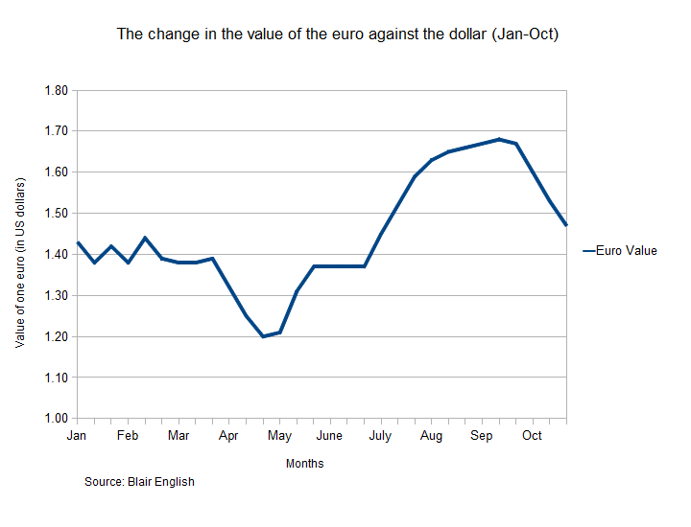

**Analyst:**

'This chart shows the changes in the value of the euro against the US dollar between January and October of 2010.

As you can see, in January and February the value of one euro **fluctuated** between $1.38 and $1.45. By March, this fluctuation stopped and the value **settled down**. During the month of April, the value of the euro **plunged**. It reached its **lowest point** of $1.20 at the end of April. During May, the value of the euro **recovered**. Slightly at first, but then more sharply between the middle and the end of the month. Throughout the month of June, the value of the euro remained **constant** at a value of $1.37. But this changed in July, when the value **soared** from $1.37 to $1.66 due to fears about the level of US government debt. In August, this dramatic rise **levelled off**. This levelling off continued into the month of September, where the euro's value **peaked** at $1.68. But during October the value **fell back**, finishing the month with a value of $1.47.'