Carbon Sums

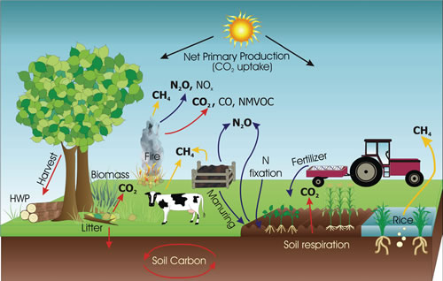

(Intro ) The diagram illustrates the circulation of the green houses.
(Description ) As shown in the picture , CO2 is primarily taken into plants during day time. Plants 'fix' each CO2 so it is no longer a gas with the help of the energy produced by the sun i.e. via the biological process of photosynthesis. The CO2 molecule can be released from the plant tissue as a gas back into the atmosphere when the plant respires, rots or is burnt. Soil organisms also release CO2 into the atmosphere via the biological process of respiration.
As you can see from the picture , nitrogen can be 'fixed' a bit like the carbon into cells but it is soil manuring rather than the plants which take the gaseous nitrogen and convert it into a non gaseous compounds. N2O is released again as a gas from the soil by other soil bugs in the biological processes of nitrification and denitrification. It is also released as a gas from animal dung and urine and when vegetation is burnt.
(Narration ) N2O has a higher residency time in the atmosphere and is therefore considered a more damaging greenhouse gas. Scientists consider that N2O has 298 times the potential to heat the world (i.e. global warming potential - GWP) compared with CO2.
Comment: in the modern approach to answering the IELTS task one writing, it is not mandatory to write up "narration ".

