**Adept Grown-ups**

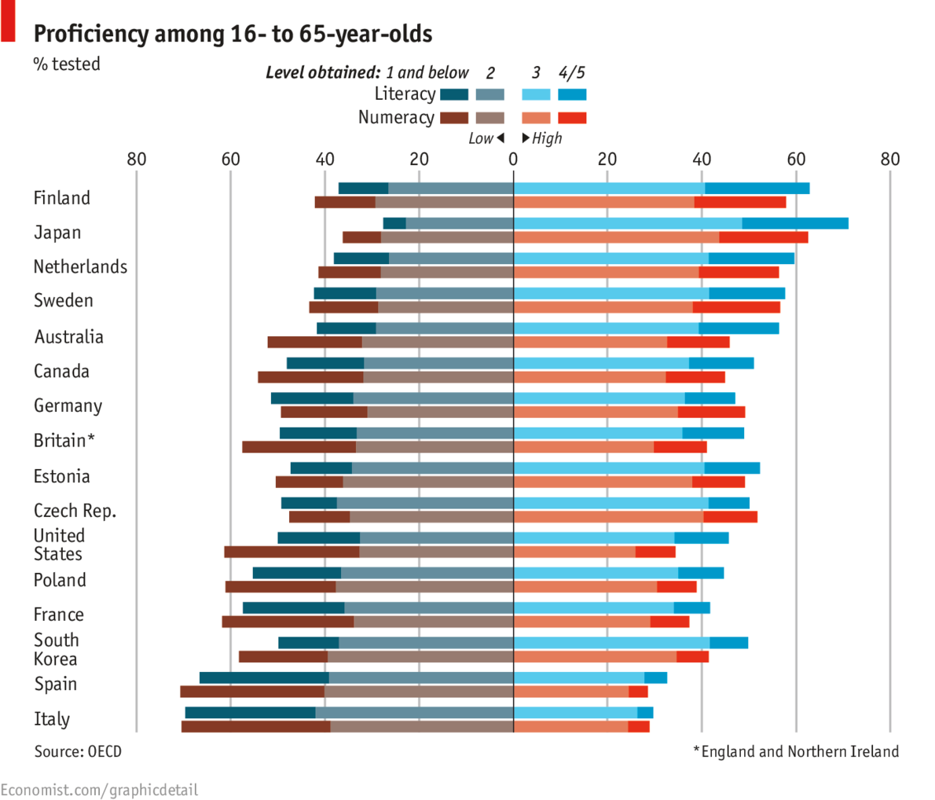

**A new study shows huge international variations in skills**

*(Dangling Subject)* HAVING spent years obsessing over pupils' performance in the OECD’s PISA study, which compares the literacy, numeracy and science skills of 15-year-olds in 22 developed countries, governments are now turning their attention to the highly variable skills of adults. New research from the OECD looks at adult literacy, numeracy and problem-solving skills. Almost **a third of** grown-ups in Italy, Spain and America showed a poor grasp of numbers, compared with **one in eight** in Finland and the Czech Republic, and less than **one in ten** in Japan. Worryingly, some university degrees turn out not to offer much advantage over good secondary-school qualifications. Those who completed school in Japan and the Netherlands but did not go on to higher education **outperformed** southern European graduates of the same age.