My Favorite Room: Katy of Sugarlaws
Katy is wearing a Topshop dress and Nine West heels. This post was inspired by the dearly missed Domino Magazine.
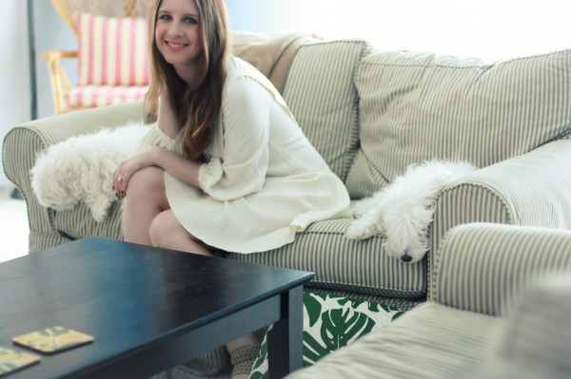

My favorite room is our living room — it’s where we spend all our time! When my husband and I moved in together, we had a lot of debate over some gender-neutral decorating choices (at least two-thirds of my prior apartment was pink). We settled on this brown and blue color scheme. I never realized how much I’d grow to love it! The room came together slowly, one detail at a time, from the antique wicker chair that was a fixture in my childhood bedroom, to the selection of my favorite cookbooks on the coffee table. The prints on our walls all have stories too. My mom bought us antique prints which are scenes of our college campuses, and the Eiffel Tower is where we got engaged! And, of course, no room would be complete without Calvin and Coco sprawled on the couches, their favorite spot to nap.”

……………………………………………………………………………………………………………………………………………
Your Favorite Place in Your House
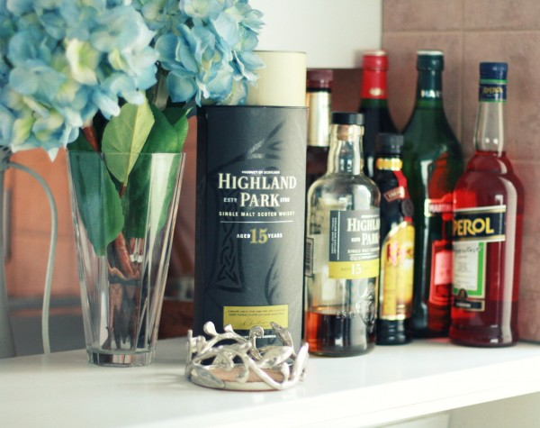
My house is quite large. It has four bedrooms, three bathrooms, a kitchen, a study, a living room, a dining room, a special games room and a big front and back garden.( intro )
My favourite room is my bedroom. I love it because it is the only room in my house where I can lock myself away from the rest of the world. After a long hard day, all I want to do is go up to my cosy bedroom and either listen to some mellow music, or lie down, unwind and watch a bit of T.V or maybe even a relaxing film. This room is very special to me because I have inhabited it for over fifteen years. It is a part of me. It is full of my personal possessions and it has been decorated with my fair hands.
So what does this special room look like? Well, it's quite big, but not huge. It's big enough to hold a double bed, which leans against the back wall of the room. There is a sofa bed, which leans against the left wall in the room. In front of the bed there is a dressing table with a large mirror. This is the place where I sit every morning and dry my hair and put on my make-up. Either side of the dressing table there are two wardrobes.
The wardrobe on the right is the one I use daily, the one on the left is full of disused toys, games, clothes and books. A bit messy! My television and video recorder are on a shelf above the dressing table. Also on this shelf, there is a selection of my favourite videos: Pretty Woman, Dirty Dancing, and Austin Powers. On the left hand side of my bed, to the left of the door, there is a chest of draws and on top of the chest I have my stereo. Scattered around the room. I have photos of my friends and family. These photos bring back memories of happy times spent.
………………………………………………………………………………………………………………………………………..

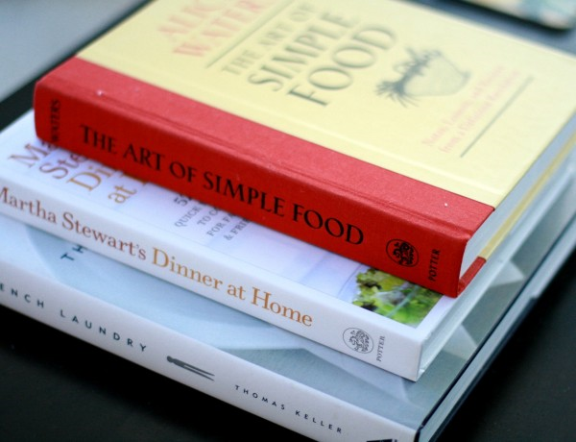

What is Your Favorite Place in Your House?
My favorite room is my living room - it has cranberry red walls, lots of wood, lovely dark floors and high ceilings. I have my good speakers set up in this room and all the furniture is really comfortable. In the winter I keep a fire going pretty well 24X7. This is the room in which I listen to music (when I'm in serious listening mode as opposed to background listening), where I read, where I visit with my friends.
If it wouldn't totally kill the ambiance (sp?) I'd probably put my computer down there. As it is I often use my laptop in this room and I think I do most of my writing in this room, now that I think about it, too.'
Man, I'd be lost without it.

