

**Deteriorating Titanic**

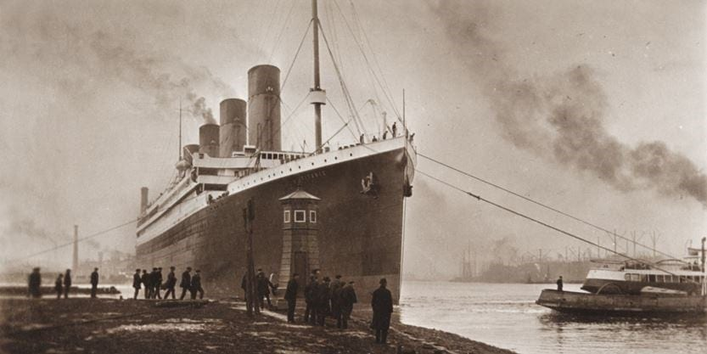

## At 11:39 p.m. on the evening of Sunday, 14 April 1912, lookouts Frederick Fleet and Reginald Lee on the forward mast of the Titanic sighted an eerie, black mass coming into view directly in front of the ship. Fleet picked up the phone to the helm, waited for Sixth Officer Moody to answer, and yelled “Iceberg, right ahead!” The greatest disaster in maritime history was about to be set in motion.

Thirty-seven seconds later, despite the efforts of officers in the bridge and engine room to steer around the iceberg, the Titanic struck a piece of submerged ice, bursting rivets in the ship’s hull and flooding the first five watertight compartments. The ship’s designer, Thomas Andrews, carried out a visual inspection of the ship’s damage and informed Captain Smith at midnight that the ship would sink in less than two hours. By 1 2:30 a.m., the lifeboats were being filled with women and children, after Smith had given the command for them to be uncovered and swung out 15 minutes earlier. The first lifeboat was successfully lowered 15 minutes later, with only 28 of its 65 seats occupied. By 1:15 a.m., the waterline was beginning to reach the Titanic’s name on the ship’s bow, and over the next hour, every lifeboat would be released as officers struggled to maintain order amongst the growing panic on board.

## The dosing moments of the Titanic’s sinking began shortly after 2 a.m., as the last lifeboat was lowered and the ship’s propellers lifted out of the water, leaving the 1,500 passengers still on board to surge towards the stern. At 2:17 a.m., Harold Bride and Jack Philips tapped out their last wireless message after being relieved of duty as the ship’s wireless operators, and the ship’s band stopped playing. Less than a minute later, occupants of the lifeboats witnessed the ship’s lights flash once, then go black, and a huge roar signalled the Titanic’s contents plunging towards the bow, causing the front half of the ship to break off and go under. The Titanic’s stem bobbed up momentarily, and at 2:20 a.m., the ship finally disappeared beneath the frigid waters.

## What or who was responsible for the scale of this catastrophe? Explanations abound, some that focus on very small details. Due to a last-minute change in the ship’s officer line-up, iceberg lookouts Frederick Fleet and Reginald Lee were making do without a pair of binoculars that an officer transferred off the ship in Southampton had left in a cupboard onboard, unbeknownst to any of the ship’s crew. Fleet, who survived the sinking, insisted at a subsequent inquiry that he could have identified the iceberg in time to avert disaster if he had been in possession of the binoculars.

## Less than an hour before the Titanic struck the iceberg, wireless operator Cyril Evans on the California, located just 20 miles to the north, tried to contact operator Jack Philips on the Titanic to warn him of pack ice in the area. “Shut up, shut up, you’re jamming my signal,” Philips replied. “I’m busy.” The Titanic’s wireless system had broken down for several hours earlier that day, and Philips was clearing a backlog of personal messages that passengers had requested to be sent to family and friends in the USA. Nevertheless, Captain Smith had maintained the ship’s speed of 22 knots despite multiple earlier warnings of ice ahead. It has been suggested that Smith be under pressure to make headlines by arriving early in New York, but maritime historians such as Richard Howell have countered this perception, noting that Smith was simply following common procedure at the time, and not behaving recklessly.

## One of the strongest explanations for the severe loss of life has been the fact that the Titanic did not carry enough lifeboats for everyone on board. Maritime regulations at the time tied lifeboat capacity to the ship size, not to the number of passengers on board. This meant that the Titanic, with room for 1,178 of its 2,222 passengers, actually surpassed the Board of Trade’s requirement that it carry lifeboats for 1,060 of its passengers. Nevertheless, with lifeboats being lowered less than half full in many cases, and only 71 2 passengers surviving despite a two-and-a-half-hour window of opportunity, more lifeboats would not have guaranteed more survivors in the absence of better training and preparation. Many passengers were confused about where to go after the order to launch lifeboats was given; a lifeboat drill scheduled for earlier on the same day that the Titanic struck the iceberg was cancelled by Captain Smith in order to allow passengers to attend church.

### Questions 1-6

Complete the table below. Choose ***NO MORE THAN TWO WORDS*** from the text for each answer. Write your answers in boxes ***1—6*** on your answer sheet.

|  |  |  |  |
| --- | --- | --- | --- |
| **Time** | **Person’s** | **Position** | **Action** |
| 11:39 p.m | 1 | 2 | Reported sighting of iceberg |
| 3 | Andrews | Ship’s designer | Reported how long the Titanic could stay float |
| 12:15 a.m | Smith | Captain | Ordered 4 to be released |
| 2:17 a.m | Bride & Philips | 5 | Relayed fina |

### Questions 7-13

Do the following statements agree with the information given in Reading Passage 1?

In boxes ***7—13*** on your answer sheet, write

|  |  |
| --- | --- |
| TRUE | if the statement agrees with the information |
| FALSE | if the statement contradicts the information |
| NOT GIVEN | If there is no information on this |

7 -The binoculars for the men on watch had been left in a crew locker in Southampton.

8 -The missing binoculars were the major factor leading to the collision with the iceberg.

9- Philips missed notification about the ice from Evans because the Titanic’s wireless system was not functioning at the time.

10- Captain Smith knew there was ice in the area.

11- Howell believed the captain’s failure to reduce speed was an irresponsible action.

12- The Titanic was able to seat more passengers in lifeboats than the Board of Trade required.

13 -A lifeboat drill would have saved more lives.

Answers

**1** Answer: Fleet

**2** Answer: lookout

**3** Answer: Midnight /12:00 a.m.

**4** Answer: lifeboats

**5** Answer: wireless operators

**6** Answer: (wireless) message

**7** Answer: FALSE

**8** Answer: NOT GIVEN

**9** Answer: FALSE

**10** Answer: TRUE

**11** Answer: FALSE

**12** Answer: TRUE

**13** Answer: NOT GIVEN