**Tell Friend from Foe**

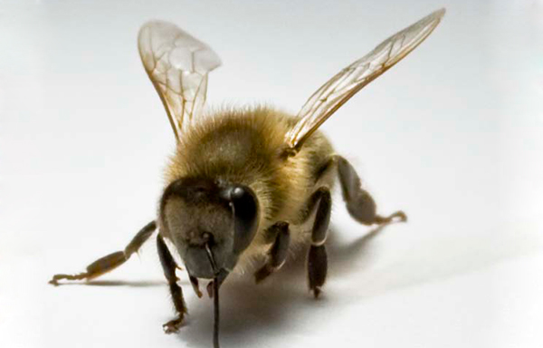

By **Jessica Shugart**

A honeybee with a clipped right antenna like this one **is** **less likely** to get aggressive with strangers **than** are bees with intact antennae. (Parallel Structure)

To avoid a scuffle, a wayward honeybee might do best to stay on a stranger’s left. That’s because honeybees preferentially use their right antenna to distinguish between comrades and intruders, researchers report June 27 in *Scientific Reports*.

The study also helps scientists understand a “big and interesting question: Why are our brains asymmetric?” says honeybee physiologist Julie Mustard of Arizona State University in Tempe. “The idea is that asymmetries allow the brain to have more area for processing complex information.”

Honeybee antennae are blanketed with a jungle of **hair-like** ***sensilla****, microscopic protrusions housing neurons that transmit sensory information to the brain.* Compared with the left antenna, the right contains more sensilla dedicated to smell, known to play a key role in honeybee communication.

In Short, The right and left sides of the bees’ brains perform different functions, making their brains more like humans’ than scientists had expected. The open question **is whether** a common genetic recipe leads to brain asymmetry across species. (Embedded Question)

**Reading Lesson:**

In Academic context reading, there should be no worries over the meaning of the "**Professional Words**" as there are almost always explained about in the same or following lines. In this text, for instance, the very word " ***sensilla*** ' is fairly defined for the reader.