**The best wedding party you have ever been to ?**

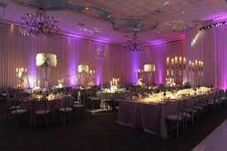

( Intro ) I've been to a LOT of weddings- most of them completely over-the-top ridiculously expensive. I have one friend who even took out a 2nd mortgage against her house to pay for everything (why!???). But... the most magical, wonderful, beautiful wedding I've been to, was a that of friend who was married in her parents backyard*. ( Thesis )*

Everything was simple, but gorgeous and full of meaning. Family and friends made the food, other friends took turns playing DJ, and a bunch of family members let them borrow their antique china sets, so that all the placesettings were different. The centerpeices were all wildflowers that were lined up in simple mason jars- and yet everything was still so elegant and intimate. It was everything a wedding should be- a celebration of love and family. Not a display of how much money you have and were willing to spend, and how popular you are with a huge guest list. It was absolutely perfect.

Elle Anderson