Some people prefer to eat at food stands or restaurants. Other people prefer to prepare and eat food at home. Which do you prefer?

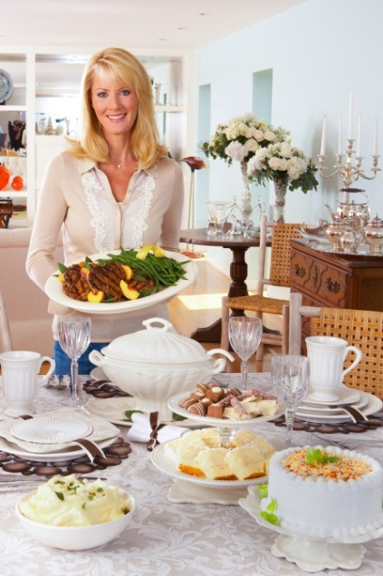

To eat at home or to eat at restaurants! An estimated seventy years ago, there were just two or three pronounces restaurants in every city. Today, nevertheless, the number of restaurants and food stands has significantly increased; one could considerably see various restaurants, cafes, buffets and the like through cities. Albeit, in today` hectic and rat-racing world , groups of people prefer to eat their daily meals out of home, from where I stand, cooking at home would be far more beneficial.

For the very one thing, health-wise, preparing food at home turns out to be healthier as it gives you much more space to change and adjust the recipe in due accordance with you and your guests' taste or diet ; as an instance, when you want to make a dish for your family and a member is suffering from dire high-cholesterol, you could comfortably use olive oil and eliminate or decrease cheese and high-fat meats from its ingredient, briefly you will change it on your own taste and will make it healthier. Moreover, no longer do different types of pollutions and impurities which are rising from unhealthy and unclean food, harm your family because you obviously care about the materials and consume fresh vegetables, high-quality meats, low-fat dairies and so on.

Aside from the health perspective , preparing dishes at home would be highly affordable. In nearly every restaurants the cost of lateral expenses ----- electricity and water consumption, employees wage and tax---- are usually included so the prices are definitely higher than the homemade. Additionally, cooking turns out to be a great and – at times an artisan-- craft , it undoubtedly gives us sense of confidence and competence. By making delicious, superb dishes you worthily expose your art and capabilities to others.

To wind up, I am of the sheer notion that cooking and eating at home is followed by truck-loads of advantages either physically , mentally and financially. Once you eat the homemade food you and your family will be health, your expenditures will reduce and you will feel more confidence.

By : Azadeh