**Super Snazzy Sazzy!**

**When it comes to** being a mother and wife besides managing a dynamic career, Sazzy Falak is a prime example of having it all under control. *(Dangling Subject)*

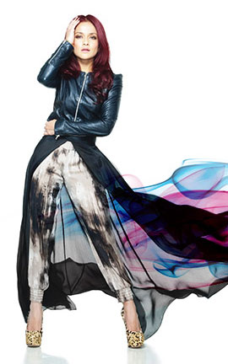

Entertainment personality Sazlini Shamsul Falak – popularly known as Sazzy Falak – has come a long way since her silver screen debut in 2005, when she starred in ‘Gol & Gincu’. Aside from her career as an actress and television host, she recently garnered international attention through the success of her fashion label – Street Fashion (SF) by Sazzy Falak.   
  
  
She admits that her celebrity status can be a bane at times. From the lack of freedom to constantly being scrutinised, the pressure that comes with fame can be quite overwhelming. However, the star retains her composure by travelling. “I get to be myself, and I get to look at people without being stared at. Not that I don’t appreciate where I am now, but I just need to get away at times!” she exclaims.   
  
**When it comes to the designs ,** this fashion mogul recently graced the PLITZS New York Fashion Week – a remarkable feat for a fashion house that is only slightly more than a year old. Sazzy Falak says the experience was truly exciting and overwhelming at the same time. “Just being able to experience work in another country is a dream come true. Of course, I still have a long way to go, and I’d like to keep on going.”   
  
  
**When it comes to parenting,** Sazzy Falak adopts a show-by-example approach. “Rather than telling them what to do, I pretend that I really love doing something so much – and they follow along”. She also believes in being a relaxed parent, preferring to let her daughters learn from their mistakes instead of controlling their every move.   
She confesses that motherhood has enhanced her time management skills greatly, as she needs to ensure that all the components of her life receive the attention they deserve. She has also discovered that she is a very patient person**, contrary to** what she had previously believed.   
  
Despite her jam-packed schedule, she makes it a point to exercise regularly alongside her husband. Both share similar interests **when it comes to sports** and physical activities, having gone rock climbing and running marathons together. “We don’t need to force ourselves to exercise – it’s really a way of life,” she says.   
  
She also considers healthy eating a priority, especially when it comes to her family. With both her parents being vegetarian, Falak herself is largely a pescetarian (someone who eats fish, but not meat) and tries to consume only organic products at home whenever possible. “The things I put in my body are very important. If I eat junk, I feel like junk,” she says.