**THE OPIUM IS OUR CHILDREN**

**By: Roy Steward**

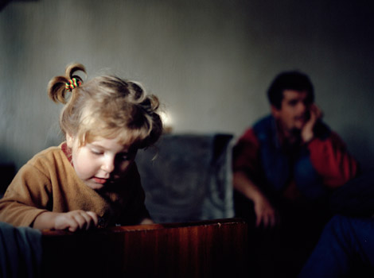

(intro) If a Roman senator’s opium was his public life, a Viking’s was battle. Our ancestors have been addicted to honor, craved virtue and wealth, been hooked on conquest, and on adventure. But ours is the first civilization to find its deepest fulfilment in its descendants. Our opium is our children.(Thesis)

For one , people who might once have been public figures, deeply invested in their work, are instead busy serving their children. Ours is a culture not of ancestor worship but of descendant worship. Children must sense that nothing an adult does is more important than their own desires. All political questions seem to come down to the interests of "the next generation".

I am reminded of the philosopher who was informed by a lady that the world rested on a turtle. When asked what the turtle rested on, she replied it was "turtles all the way down". Our purpose is our children, whose purpose is their children. And so on. Each generation more important than the one before. Generation after generation, all the way down.

This seems a self-defeating, infinite regression. I’d prefer our opium to be the struggle to create a living civilization . We should seek to emulate previous generations. Our obligation cannot be uniquely to **the young** and those yet to be born. It is also to **the living**, and to **the dead**.

**Comment:**

It is quite common these days to make a plural form of a noun – referring to a group of people sharing the same interest --- by the format : The + Adjective … such as:

***The young … the old… the rich… the poor…. The Johnsons… the Johnses….***