Comparing apples with oranges
NOTHING does rankle data mavens more than analysing two things that ought not be compared. Doing so is surprisingly fruitful. Oranges were more popular for decades, but in recent years apples have squeezed ahead. Chinese expansion was the core reason for the deciduous drive. The government’s call for healthy living and serving the Russian and the Middle Eastern markets led to more apple production. In contrast, orange production has plateaued, due in part to a decline of orange juice consumption in America—around 40% less over the past 15 years. Close to the equator, oranges are more popular than apples, whereas farther north apples are more appealing, perhaps reflecting their ease of growth. To be sure, it is unfair to contrast both fruits. But it makes for juicy comparisons.
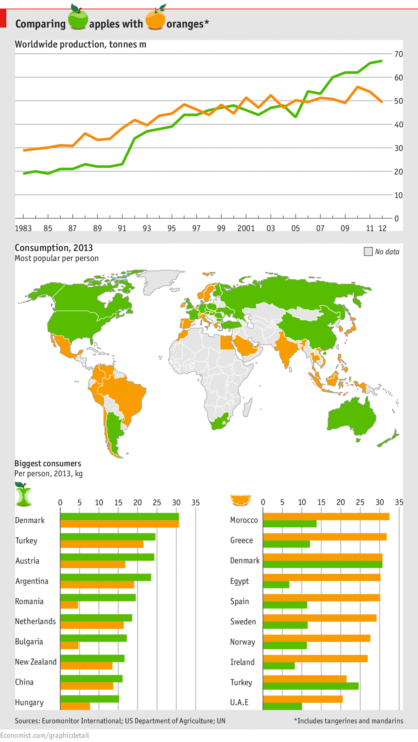
Comment :
Reading the above trend sample , pay attention to the negative form of " Ought to " which is " Ought not " without the following " to ".

