**Say ‘No’ to BO!**

**Body odour can be a major source of discomfort – not to mention embarrassment. Try these tips to stave off ma-lodours.**

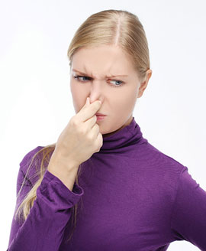

There are 3-4 million sweat glands on the average human body. That’s a lot of sweat glands – and a lot of sweat. On its own, sweat is a clear, salty liquid that’s mostly odourless. However, it also provides a rich breeding ground for the bacteria that we have on our skin. These microbes digest a protein called keratin in sweat, and the result is that pungent smell that we’re all familiar with. We’ve all experienced episodes of body odour (BO) or, as it’s known scientifically, bromhidrosis. That unmistakable pong is a constant worry, especially in a hot, humid country like ours.  
  
  
**Fighting the funk**  
  
You can banish BO simply by practising good hygiene habits and investing in a quality antiperspirant or deodorant. Here are some tips to get you started:  
  
**• Bathe daily.** A no-brainer, but regular washing will help get rid of excess sweat and bacteria.  
  
**• Dry thoroughly.** Microbes thrive in damp areas, so make sure to keep your body – especially your feet – cool and dry.  
  
**• Use a deodorant or antiperspirant.** Deodorants help mask the smell of that sweat-bacteria combo, while antiperspirants actually help reduce the amount of sweating. Antiperspirants that contain aluminium chloride help block sweat glands, rendering them dormant for a period of time.   
  
**• Don’t reuse clothing.** Sweaty clothes are a perfect breeding ground for bacteria.  
  
**• Choose appropriate clothing.** Natural fibres like cotton allow your skin to breathe. When doing vigorous activities like exercising, opt for specialised attire that can help absorb moisture.   
  
**• Watch your diet.** Some strong-smelling foods can contribute to BO, while foods that have you sweating more than usual – think spicy dishes – can exacerbate the situation.

Comment :

***" Not to mention…. "*** is quite a modern way of introducing samples if they are more than one. It is catchier and more emphatic , more complex and pretty effective in writing and in speech.