**Pride: It Brings Out the Best—and Worst—in Humans**

This two-faced emotion motivates us to achieve, intimidate others and climb the social ladder

By Jessica L. Tracy

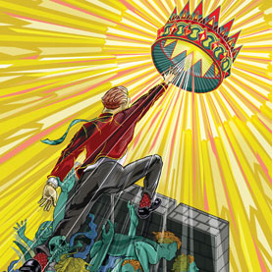

Mark Zuckerberg did not invent Facebook because he wanted to find a new way of connecting millions of people all over the world. **Nor did** he found his multibillion-dollar company solely for the money, judging by his trademark jeans and hoodie sweatshirt. He did it because he wanted to show up a girl who dumped him and the guys in Harvard's most elitist social club. The desire to prove he was smarter than them gave Zuckerberg the motivation he needed to start on a path toward becoming one of the world's preeminent innovators. Many successful people—Bill Gates, Margaret Thatcher and physicist Murray Gell-Mann come to mind—are driven not simply by wealth or a desire to solve a particular problem but rather by a need to *be the person who did it*. They want to feel pride. ( Thesis )

Comment: when the negative adverbs stand at the threshold of the sentence , they are usually followed up by the modal verbs , derived out of the main verb.