### The threat in the pocket

### Which one is less secure : Mobile or Pc?

### BY: N.V. | LOS ANGELES

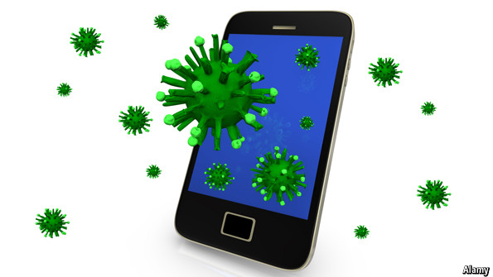

**GIVEN all the talk about mobile malware**—Trojans, viruses, keyloggers, phishing expeditions and other scams infecting the phones in people’s pockets—users might be forgiven for thinking cybercrooks are cleaning up at their expense. Truth is, surprisingly, however, few bits of malware have found their way into mobile phones. More by accident than design, smartphones have turned out to be much tougher to infect than laptops and desktop PCs. At least, that is the case at present. (Thesis)   
  
On the one hand, Makers of security software would like mobile-phone users to think otherwise. Everywhere Babbage turns these days there is yet another white paper on the threat of mobile malware. Adverts, too—online and in print—warn increasingly of the dangers of texting and talking, searching and surfing without some from of protection against malicious software. Individuals should take note, but the warnings are aimed primarily at IT professionals in firms where employees are allowed to use their own phones and tablets to connect to company networks.  
  
On the other, mobile malware is still very much in its infancy. Adrian Ludwig, Google’s top security engineer, reckons only one in 100,000 apps downloaded by Android users from all sources, legitimate or otherwise, pose any threat. After surveying two networks with some 380m users between them, the Georgia researchers found fewer than 3,500 phones with signs of having been infected by malware—ie, one in 108,000. **Given that there are** around 1.5 billion smartphones and tablets in the world, probably fewer than 15,000 mobile devices are harbouring mischievous software of some sort.  
  
Another reason why mobile phones have so far remained largely free of malware is because they lead such sheltered lives. Most users download any apps they want (the average is around 40) from one or other of the two official locations: Google’s Play Store for Android devices, and Apple’s App Store for iPhones and iPads. Both are reasonably well policed. Despite its laissez-faire reputation, Google’s marketplace for apps is curated far better than third-party sites, though nowhere near as rigorously as Apple’s.  
  
With 1m apps available for the Android operating system and over 750,000 for Apple’s iOS, users have little need to venture outside their walled gardens. The small minority who visit dubious download sites have only themselves to blame if their phones become infected. Third-party app stores, especially for Android devices, tend to be dens of iniquity. Most offer free apps for downloading pirate copies of **sought-after** music, video and utilities as honey-pots for the gullible. As a rule, expect anything downloaded from third-party sites to come with some form of malware embedded in it. (Concluding Sentence)   
  
**Overall,** because mobile phones, unlike laptops and desktops, are still not widely used for online banking or credit-card transactions, they tend to be of less interest to the cyberworld’s shady characters, at least for the time being.

**Comment :** " ***Given that .."*** is quite a common term , used mostly in writing and in formal speeches…. And it is widely used as a good replacing of " Considering that… Suppose that.. Taking into accounts the fact that….