Are today`s children get enough sleep ?

**Getting Enough Sleep is No Easy Task for Today's Students**

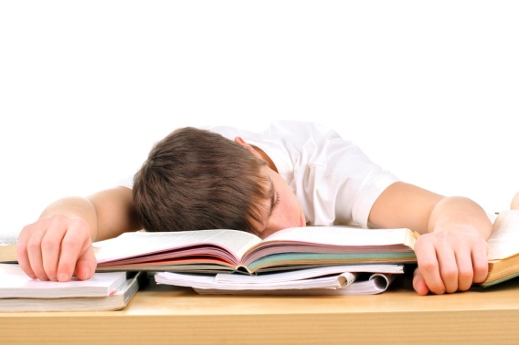

By : Alina

Take a look inside a high school classroom. *( stormy beginning)* You will most likely find a teacher at the front of the class and students sitting at their desks. Yet, look closer, and you might notice a familiar trend: many of these students are not paying attention. Instead, they are dozing off or even completely asleep.

**Today,** an overwhelming majority of high school students are not getting enough sleep. This lack of sleep is a serious problem, especially as students are doing more than ever with their time. They come to school early, spend hours listening to teachers and taking tests, then run off to practices and meetings, and come home to be faced with even more work. And the homework load these days is not light; teachers assign hours worth of homework each night. Our nation’s teenagers require just as much sleep as they did when they were younger, and they are simply not getting this much needed rest.

Most **these** kids need at least nine hours of sleep per night in order to function properly. Yet the period of this nine hours shifts as a child gets older. After puberty, the body’s internal clock changes so that it is difficult for teens to fall asleep before 11pm2. So even if a student falls asleep at eleven, they would need to sleep until at least 8am to get a full night's sleep. Considering the time at which most high schools in this country begin, those nine hours are clearly being cut short. Few high schools starts after 8am. However, there are schools that have paid attention to this research and pushed forward the start of their school day.

**In schools** where the start time is after 8:30 in the morning, the faculty and staff believe that there has been a real change in their students. They note that the students miss class less, pay more attention in class, perform better in class, and report lower levels of depression. These changes are clearly not just coincidental. The researchers of these studies suggest that the results are quite significant and that more schools should consider pushing up their start times. Another issue is the time when standardized tests are given. Most of these tests are given at 8am, which can, in fact, hinder the performance of otherwise intelligent kids. Out of all of the times in the school day, 8am results in the poorest scores, since the brains of the kids are not fully functional at this time.

**So** exactly how much sleep are teens in our nation getting? Over 50% of high school students report that they sleep seven hours or less each night, and about one in five get less than six hours. And 82% of both middle and high school students said that they woke up tired and unrefreshed, and more than half had trouble concentrating in school. These statistics are overwhelming. We are making it so much harder for kids to learn by forcing them to wake up so early. And the consequences of not getting enough sleep are severe.

**All in all,** teens all over the world need the same amount of sleep, and they need it at the same times. Yet, it seems as the whole world may *be turning a blind eye to* this serious topic.

Comment:

It is quite a common practice to link the paragraphs, using some **linking devices** and words in the topic sentence which links it to the previous paragraph. In this very article, such linking devices are adeptly deployed . You can find them bold and underlined.