**Guilty pleasures: What's the cost of being a couch potato?**

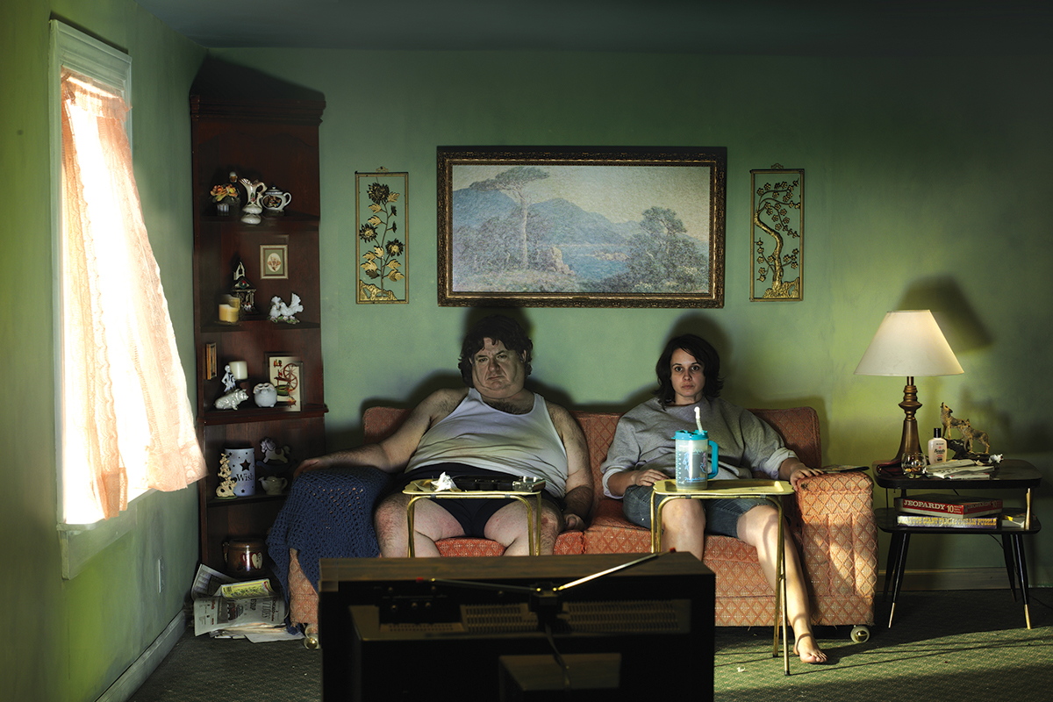

( stormy beginning) Sitting is the new smoking. Sedentary lifestyles are being blamed for cardiovascular disease, diabetes and even some other types of ailment, and the World Health Organization recommends that adults do two and half hours of moderate exercise or 75 minutes of intense exercise each week. Whilst Couch potatoes may scoff at this idea, and they are in good company: around half of people in the US, as well as 37 per cent of men and 45 per cent of women in England, fail to do even this modest amount, “Any exercise is better than nothing," says Chris Easton at the University of the West of Scotland in Paisley, UK.