**How We Learn**

**Insights from psychology can make us better readers, writers and thinkers**

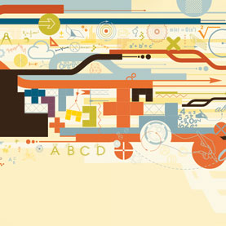

When we pack our children off to school, we envision them embarking on a lifelong career of learning. Yet one thing they typically never study is the art of studying itself. Our intuitions, it turns out, do not always map to reality. In “[Psychologists Identify the Best Ways to Study](http://www.scientificamerican.com/article.cfm?id=psychologists-identify-best-ways-to-study)” by John Dunlosky et al. we comb through the vast scientific literature on learning techniques to identify the two methods that work best.

In an increasingly digital world, one shift in learning has gone largely unremarked: the decline of handwriting. Different brain activity accompanies a hand scribbling on paper or typing, with the former invoking neuronal circuits of movement and spatial processing. As we abandon our pens and pencils in favor of the keyboard, is our engagement with words becoming more superficial? “The Science of Handwriting,” by Brandon Keim investigates this question.

Yet we need not fear change: as education data illustrate all too well, the number of degrees in mathematics, science and engineering is not keeping pace with demand. To better prepare students for the world they will one day encounter, a dramatic rethinking of how math and science are taught may be in order. “New Techniques Make Math Fun for All” by John Mighton describes one popular approach that has helped struggling students discover an untapped aptitude.

Strong foundations can nurture exploration at all ages. Had it not been for an abiding love of learning, the 49-year-old Julia Child would not have published the cookbook that then launched her culinary career. Grandma Moses would not have taken up painting in her late 70s. And two octogenarians would not have spent 2013 vying to become the oldest climber to summit Everest. Whatever your quest, the science of learning can help you reach it*. (Concluding Sentence )*