**The Psychological Effects of TV News**

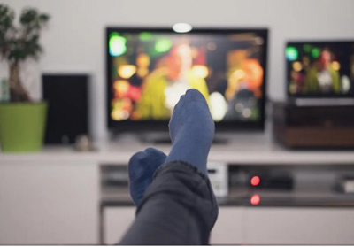

We’ve known for a very long time that the emotional content of films and television programs can affect your psychological health. It can do this by directly affecting your mood, and your mood can then affect many aspects of your thinking and behaviour. If the TV program triggers negative mood experiences (e.g. anxiety, sadness, anger, disgust), then these experiences will affect how you interpret events in your own life, what types of memories you recall, and how much you will worry about events in your own life.

There are a lot of **not-so-pleasant** things that happen in the world, (Euphemism) and it is probably right that people should know about these things through their reporting in news bulletins. These ‘bad things’ include crime, famine, war, violence, political unrest, and injustice, just to name a few. But there is also an increasing tendency for news broadcasters to ‘emotionalize’ their news and to do so by emphasizing any potential negative outcomes of a story no matter how low the risks of those negative outcomes might be. This is basically ‘scaremongering’ at every available opportunity in order to sensationalize and emotionalize the impact of a news story. Because we now have 24-hour news coverage, gone are the days when a correspondent or journalist’s role was simply to impartially describe what was happening in the world – because of satellite TV we have an almost immediate and imminent visual record of what is happening throughout the world. So the journalist’s job then becomes one of ‘evaluating’ the news story and it is only a small step from ‘evaluating’ a story to ‘sensationalizing’ it. As professor of journalism studies Bob Franklin wrote some years ago:

“Entertainment has superseded the provision of information; human interest has supplanted the public interest; measured judgement has succumbed to sensationalism.”

News bulletins also have to compete with entertainment programs for their audience and for their prime-time TV slot, and seem to do this by emphasizing emotionally relevant material such as crime, war, famine, and the like at the expense of more positive material.

Notwithstanding, what was more interesting was the effect that watching negative news had on peoples’ worries. We asked each participant to tell us what their main worry was at the time, and we then asked them to think about this worry during a structured interview. We found that those people who had watched the negative news bulletin spent more time thinking and talking about their worry and were more prone to catastrophise their worry than people in the other two groups. Catastrophizing is when you think about a worry so persistently that you begin to make it seem much worse than it was at the outset and much worse than it is in reality – a tendency to make ‘mountains out of molehills’!

So not only are negatively valenced news broadcasts likely to make you sadder and more anxious, they are also likely to exacerbate your own personal worries and anxieties. We would intuitively expect that news items reflecting war, famine and poverty might induce viewers to ruminate on such topics. But the effect of negatively valenced news is much broader than that – it can potentially exacerbate a range of personal concerns not specifically relevant to the content of the program itself. So, bombarding people with ‘sensationalized’ negativity does have genuine and real psychological effects. Given this ‘cascading’ effect of negativity into people’s personal lives, should TV schedsulers be required to consider such effects when preparing and scheduling programs containing emotively negative content?