**Should cell phones be banned in school?**

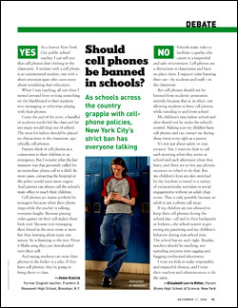

**YES**

*(Dangling Subject)* Being a former public-school teacher, I can tell you that cell phones don't belong in the classroom. A student with a cell phone is an uninterested student, one with a short attention span who cares more about socializing than education.

When I was teaching, all too often I turned around from writing something on the blackboard to find students text-messaging or otherwise playing with their phones.

Come the end of the term, a handful of students would fail the class and far too many would drop out of school. The onus for failure should be placed on distractions in the classroom, specifically cell phones.

Parents think of cell phones as a connection to their children in an emergency. But I wonder what the last situation was that genuinely called for an immediate phone call to a child. In most cases, contacting the hospital or the police would seem more urgent. And parents can always call the school's main office to reach their children.

Cell phones are status symbols for teenagers because when their phone rings while the teacher is talking, everyone laughs. Because playing video games on their cell makes them look cool. Because text messaging their friend in the next room is more fun than learning about topic sentences. So is listening to the new Three 6 Mafia song they just downloaded onto their cell.

( conclusion ) And saying students can store their phones in the locker is a joke. If they have cell phones, they're going to bring them to class.

By: Jesse Scaccia

**NO**  
Schools make rules to facilitate a quality education in a respectful and safe environment. Whilst Cell phones are a distraction in classrooms and have no place there, still I believe they should not be banned from students' possession entirely, because that is**, in effect,** not allowing students to have cell phones while traveling to and from school.

My children's time before school and after should not be under the school's control. Making sure my children have cell phones and can contact me during those times is my right as a parent.

It's not just about safety or reassurance. Yes, I want my kids to call each morning when they arrive at school and each afternoon when they leave, and there are so few pay phones anymore on which to do that. But my children's lives are also enriched by the freedom to travel to a variety of extracurricular activities or social engagements without an adult chaperone. That is only possible because an adult is just a phone call away.

If my children are not allowed to keep their cell phones during the school day—*off* and in their backpacks or lockers—the school system is governing my parenting and my children's behavior during non-school time. The school has no such right. Besides, teachers should be teaching, not spending precious time tagging and bagging confiscated electronics.

(Conclusion) I trust my kids to make responsible and respectful choices, and I trust their teachers and administrators to do the same.

BY: Elizabeth Lorris