**Biggest Diet Mistakes**

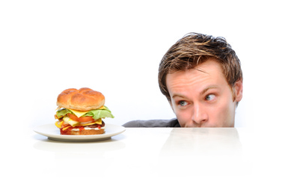

( Stormy Beginning ) So you've committed to a healthy-eating plan in an effort to lose weight. Good for you! But did you know you could be stacking the deck against yourself?

Losing weight shouldn't feel like torture. And completely swearing off the foods you love is so restrictive -- it can actually make you less likely to stick to your diet plan. There are plenty of ways to enjoy decadent foods like pasta, chocolate, and pizza while dieting. The key is to find lower-calorie swaps, whether you're whipping up dishes at home, stocking up at the supermarket, or dining out.

Even if you aren't hungry first thing in the morning, do **not miss out on** breakfast. Hunger can sneak up on you, sending you into an eating frenzy that can last all day. If you can't do a big morning meal, snack on something small, like a piece of fruit or a container of light yogurt. Then have a more substantial breakfast midmorning. Also a bad idea? Skipping meals during the day in anticipation of a big dinner, like a holiday feast or a fancy meal out. Chances are, you'll end up being too hungry, which can lead to poor food choices and overeating. It's better to eat a filling breakfast and a light lunch in preparation.

Even if you pride yourself on being a label checker, you may be overlooking some important info. Specifically, the servings per container. Many seemingly single-serving foods -- like cans of soup, bottled beverages, and small bags of chips or candy -- technically contain multiple servings. So check the servings per container, and do the math. On a related note, don't assume that every item labeled organic, all-natural, or gluten-free is inherently diet friendly. Those can still be full of calories and fat. You need to read the nutritional panel to get the full picture.

You may be wondering ***what water has to do*** with weight loss. Well, casting pounds isn't just about food! It's surprisingly common to mistake thirst for hunger -- you may find yourself "starving" when you're really just dehydrated. So drink up, and drink often! But beware of beverages with too many calories, and stick with H2O, for the most part.

Know what a food faker is? It's a seemingly diet-friendly food that's simply NOT. Granola, restaurant salads, smoothies, dried fruit... all surprisingly dangerous for calorie counters. Outsmart these food fakers: Always check the nutritional info -- whether on a restaurant website or a product's nutritional panel –  
 (appositive) and don't believe the hype without getting the facts.



By : Lisa  
Diet Advice Expert