The Power of a Smile

How to Have a Healthy Smile at Every Age

Maintaining a healthy, beautiful smile throughout your life not only does make you look more attractive – it can even lower your risk of heart disease and diabetes. Brush up on these tips to safeguard your smile at any age
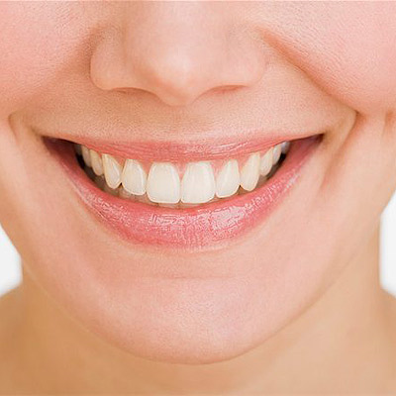

Smiles can be very moving and emotional — whether it’s a baby beaming at you, a loved one expressing joy, or even a stranger showing you some kindness. A great smile can also elicit a whole range of responses from laughter to empathy — and smiling may even make you look younger, according to a recent study conducted at the Max Planck Institute in Germany. But like the rest of our bodies, our smiles change as we age.
“In very general terms, just living life (and getting older) is going to affect your smile,” says Tom Connelly, DDS, New York City-based cosmetic dentist and weekly contributor to the Huffington Post. Your best bet for maintaining a beautiful smile from birth through your golden years is to practice good oral hygiene, go for regular dental checkups and cleanings, eat a healthy diet, and take care of any dental concerns as they arise.

Tooth Health in the Twenties and Thirties
“By the time we are in our late twenties, the biting edge of the teeth becomes totally flat,” explains Golub-Evans. The position of the teeth can also change during this period. By the time you get to your twenties and thirties, it’s more important than ever to be aware of how foods and beverages may be negatively affecting a healthy smile. Sodas, fruit drinks, sugary snacks, and even citrus fruits and tomatoes can soften tooth enamel and increase the risk of tooth decay. Dr. Lituchy also suggests being especially careful about the amount of stain-causing beverages you drink, such as red wine and coffee, since they can cause discoloration.
“Additionally, the biggest preventable foe to a great smile — besides smoking — is teeth grinding,” says Dr. Connelly. Grinding can prematurely weaken and wear down teeth over time. If you notice any teeth grinding — typically marked by increased tooth sensitivity, tired jaw muscles, and teeth that are worn down or chipped — consult with your dentist and get fitted with a night guard. “It can really help your smile,” Connelly says.

